

User Manual
Manpower Budgeting Module
www.flowhcm.com



Table of Contents
Budget Planning 3
Employee Budgeting 6
Open Positions 7
Include Position 8
Change Position 9
Transfer Position 10
Budget Approvals 11
Employee Budget Setting 12
Budget Duration 13
Position Title 14
Upload Excel 16
Employee Position 17
General Setting 18

Budget Planning
- Navigate to Others Tab and click Manpower Budgeting
- To add budget plan, click on Add Planning button in the Planning form
- Define the criteria for Positions in the Planning, the dropdown will show the positions as per filter criteria selected
- To import positions that are unmapped click on button, select the criteria and import. System will fill the grid automatically
- If required to export data of existing employees click on Export Data button
- Add description then click on Submit button to raise a requisition

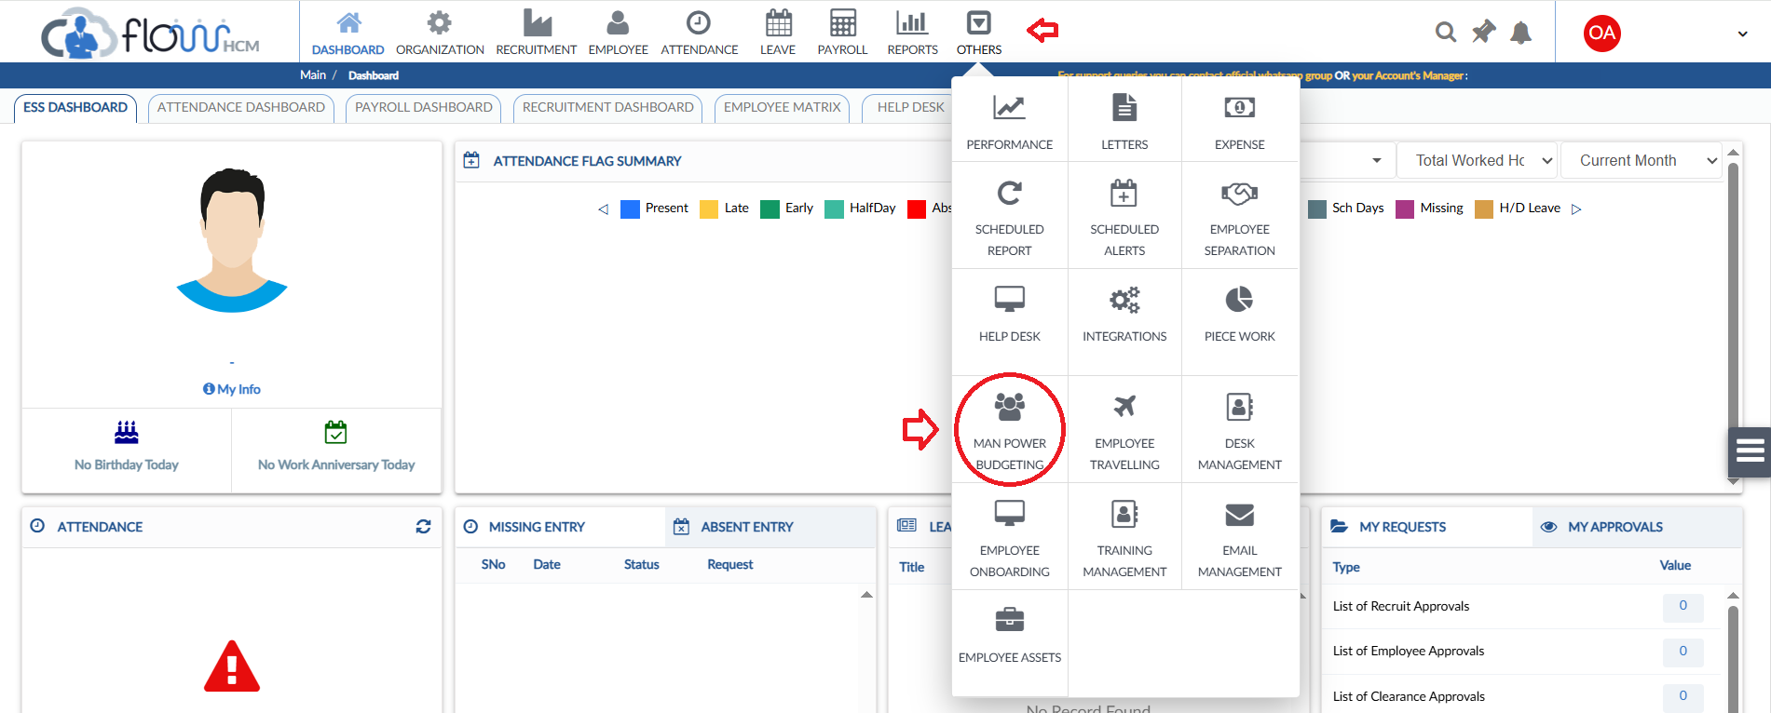
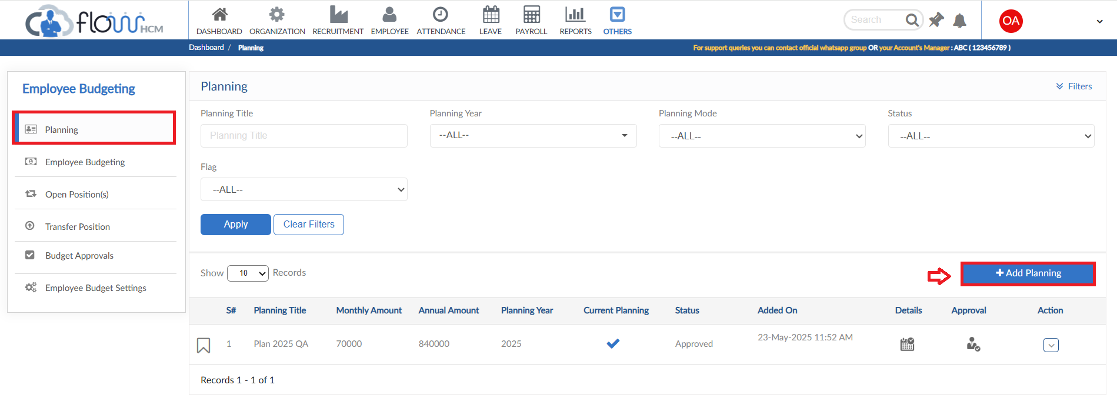
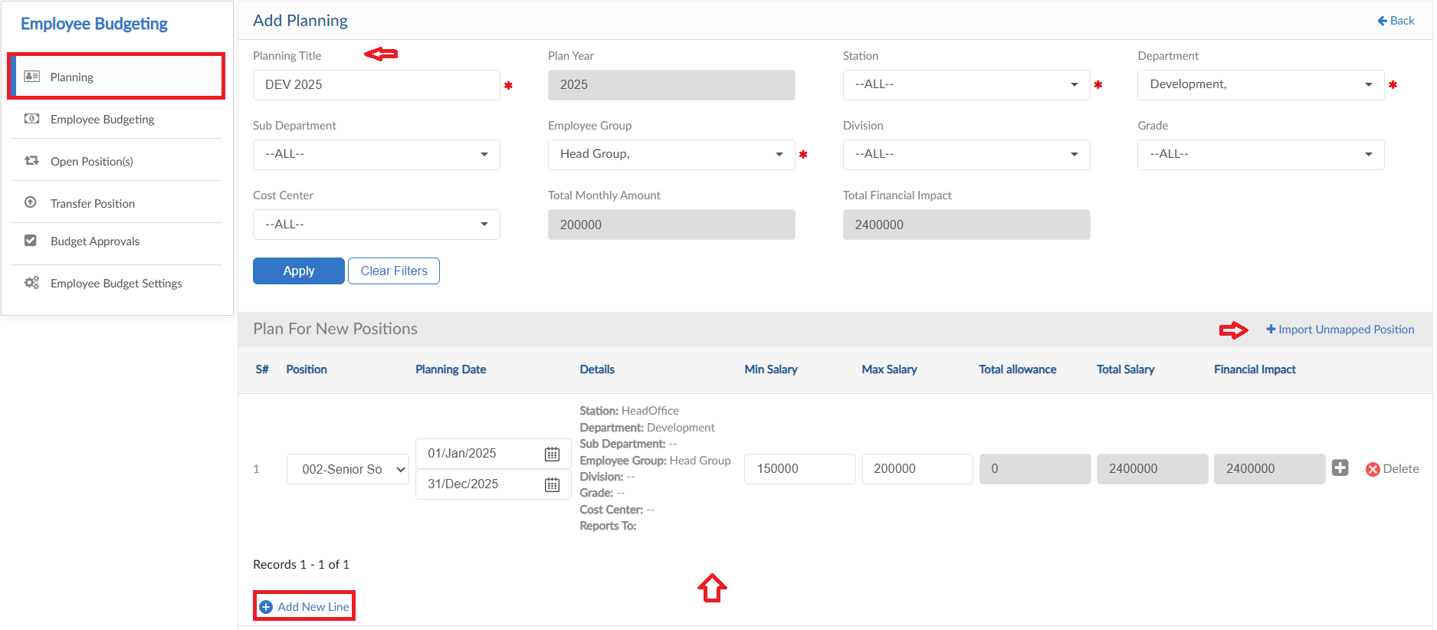
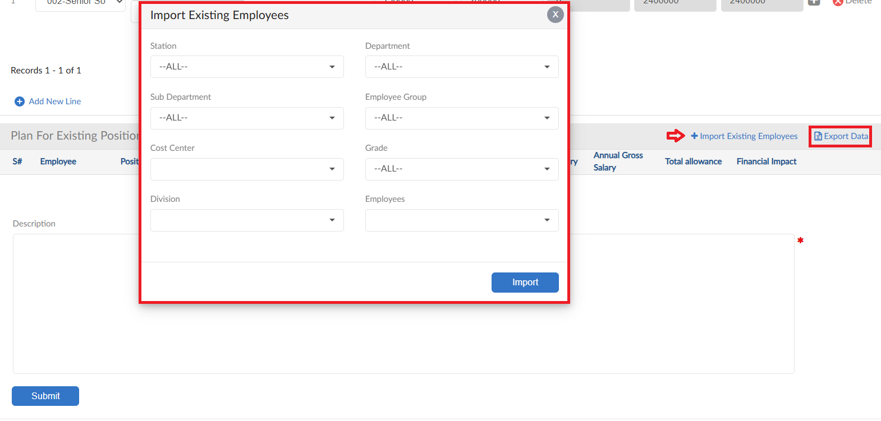
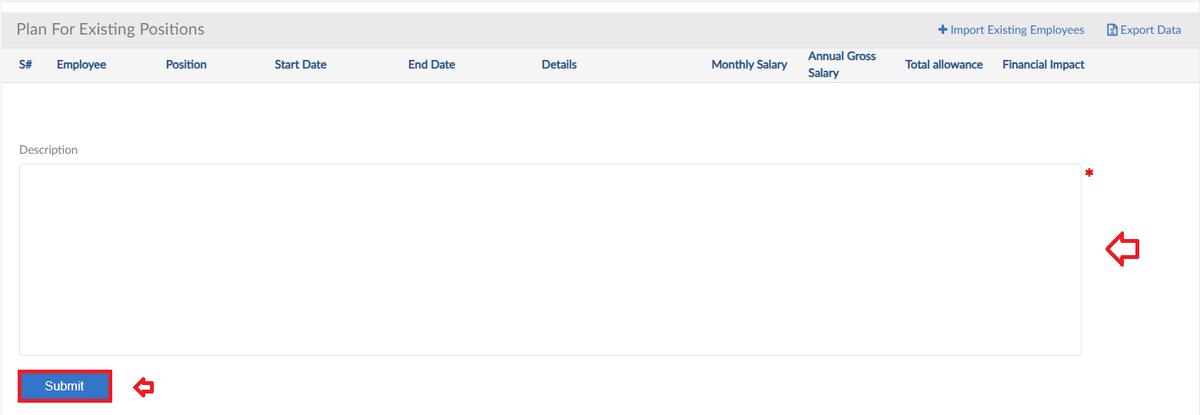

Employee Budgeting
- After submitting plan move to next tab that is Employee Budgeting (E.Budgeting)
- To add budgeting click on Add New E.Budgeting button
- Enter the Title and select Planning from dropdown
- System will automatically show the information in the field
- Add a Description then click on Submit button to raise a requisition

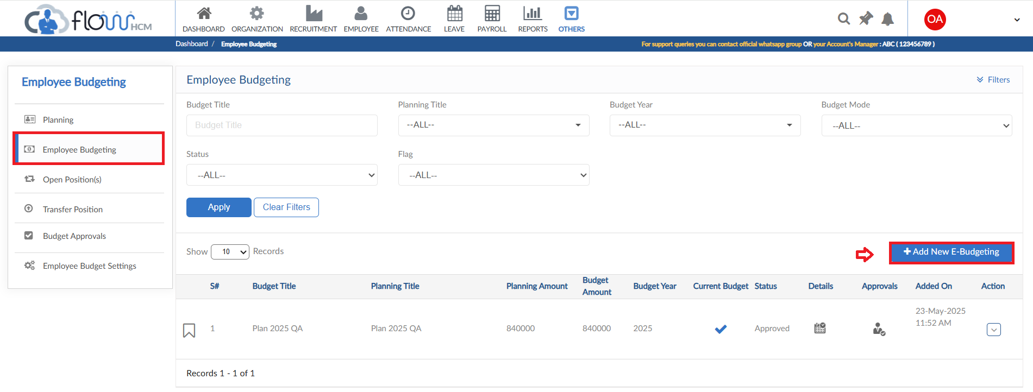
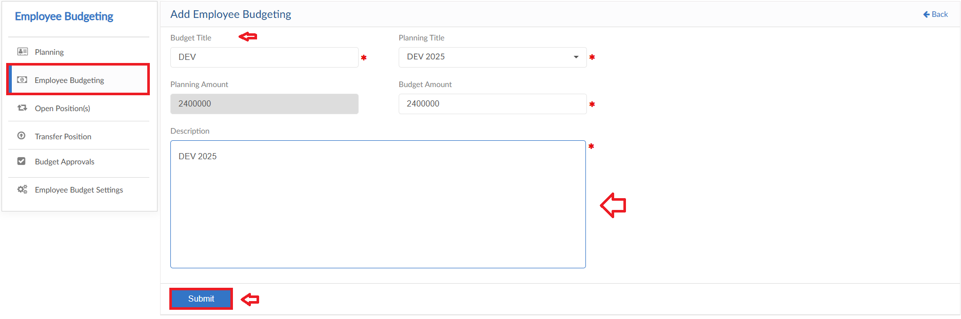

Open Positions
- Moving to next tab that is Open Positions
- This form consists of multiple functions for Planning

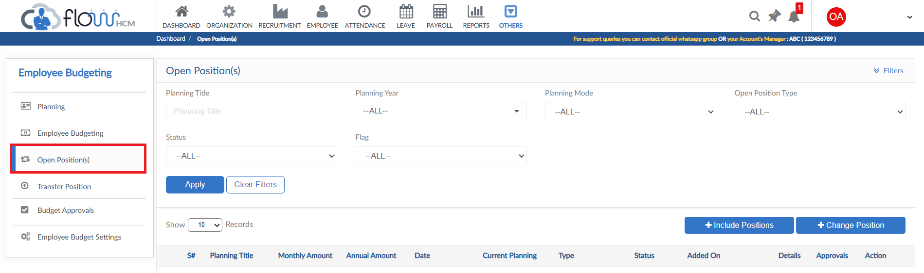

Include Position
- Click on Include Positions button in Open Positions form
- This form allows user to add more Positions in the current Planning
- Select the Planning Title from dropdown, system will show all unplanned positions
- Select Positions and define a Description
- Then click on Submit button to raise a requisition
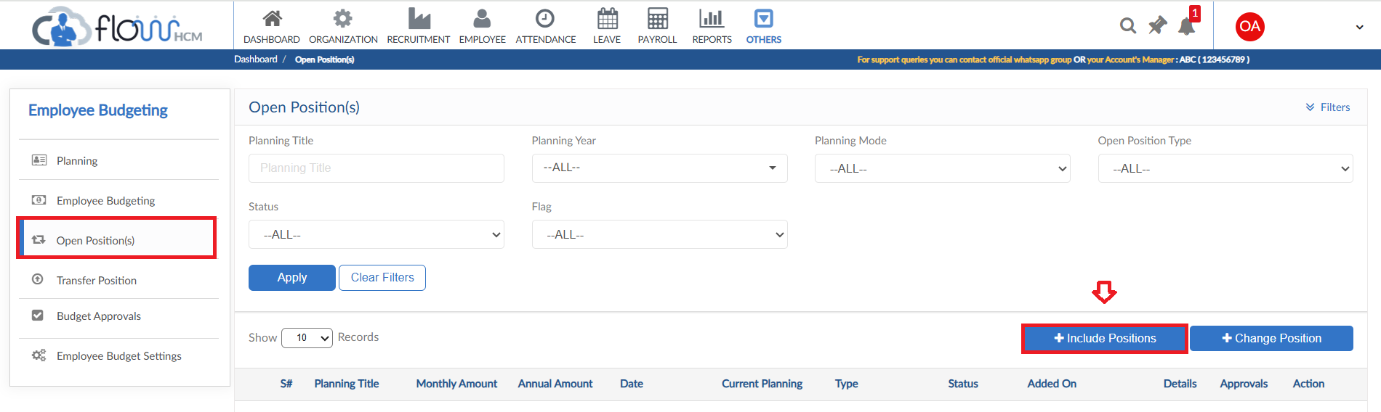
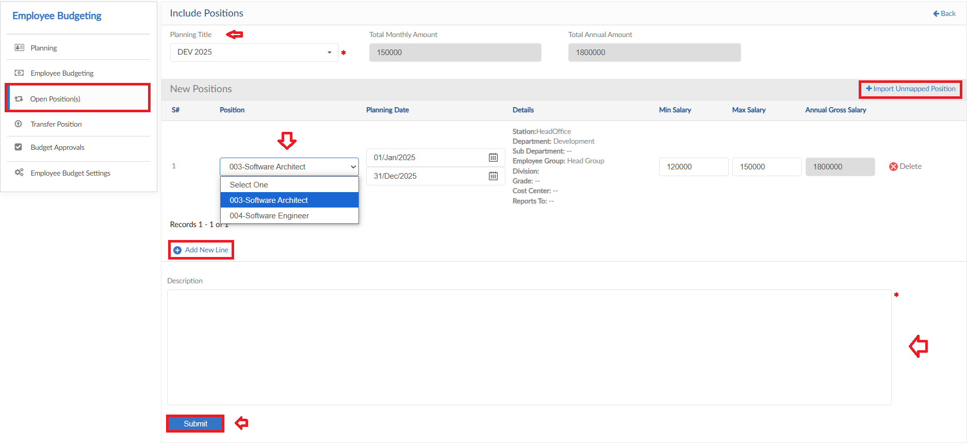

Change Position
- Click on Change Positions button in Open Positions form
- This form allows user to add strength of Positions in the selected Planning
- Select the criteria, system will show all positions of that planning
- As required change the count of positions
- Add a description then click on Submit button to raise a requisition
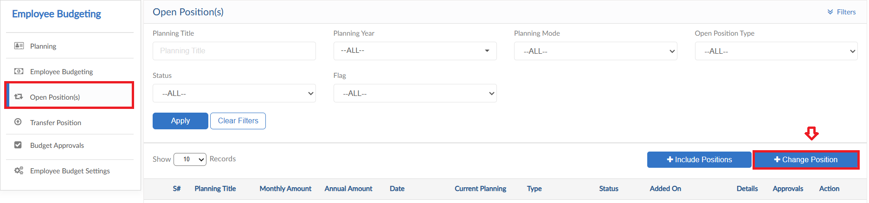
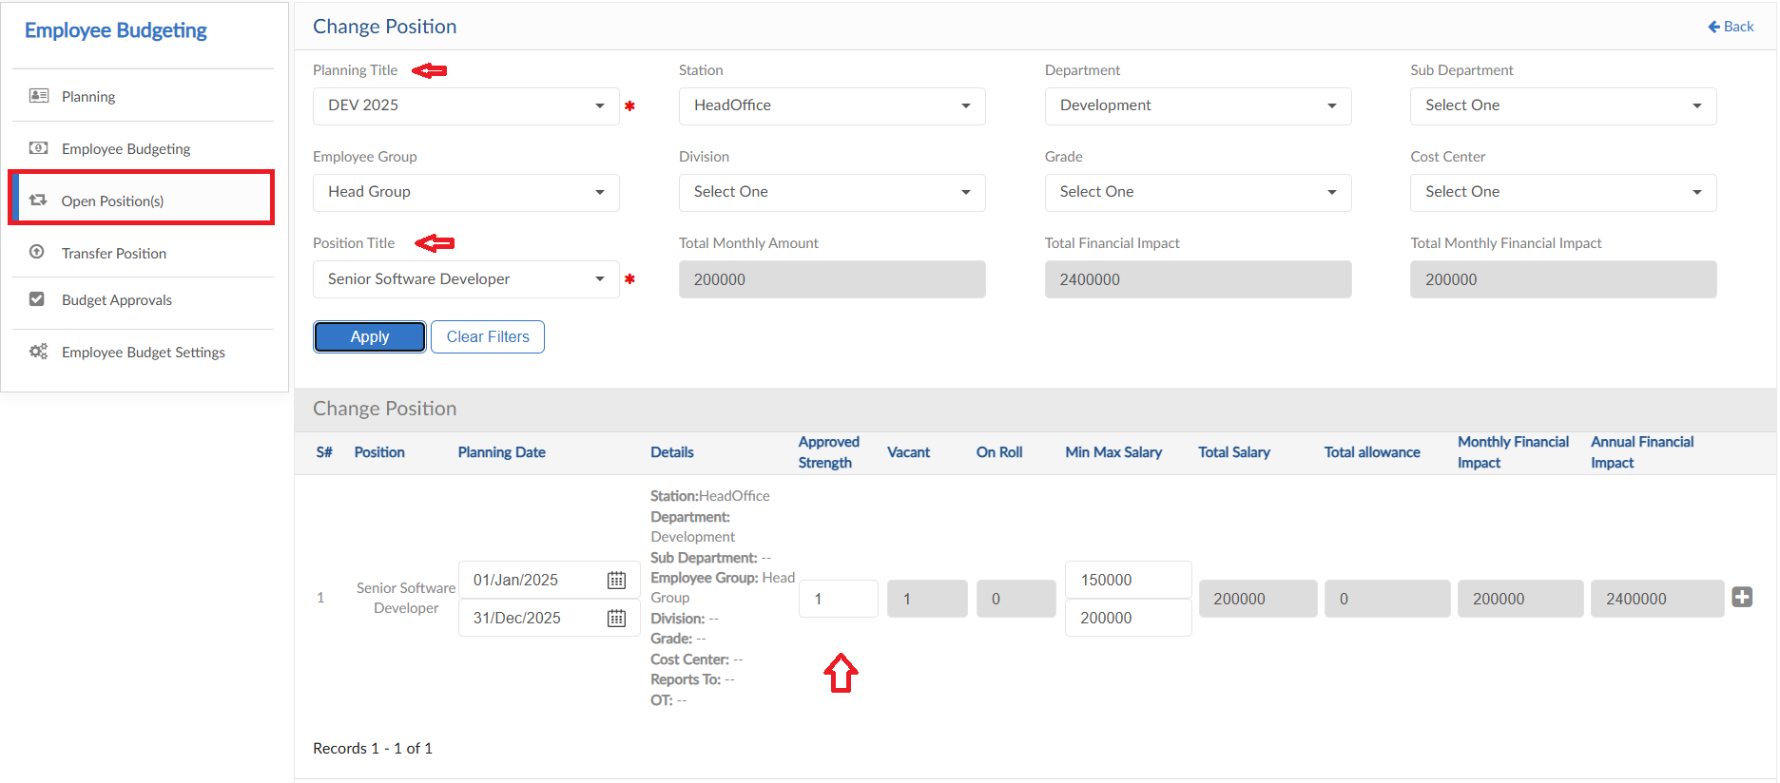
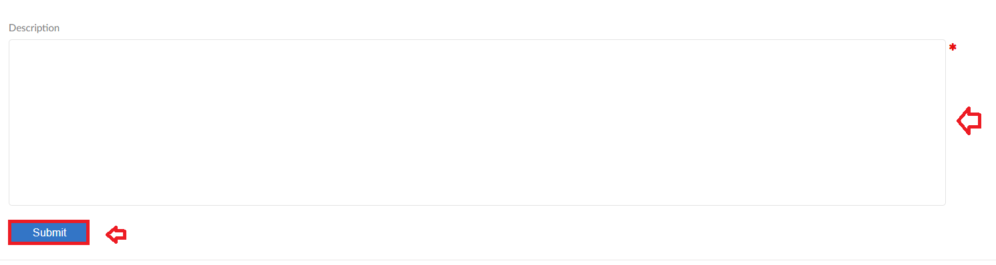

Transfer Position
- To add a Transfer Position request, click on Add Position Transfer
- Select Employee Position from dropdown, system will fill all the data in fields
- Any change made in data will be shown in the Table to the right
- Select the impact of changes either in the current Planning or not
- After details are entered add a description against request
- Then click on submit to raise a requisition
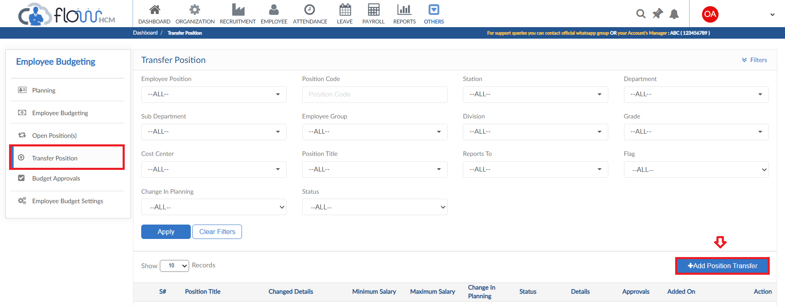
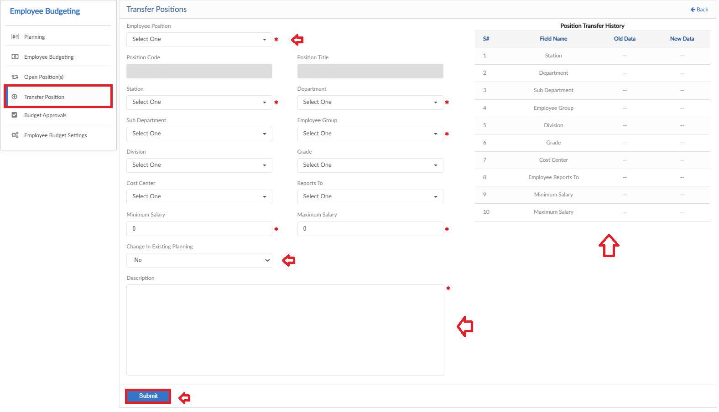

Budget Approvals
- Move to next tab of Budget Approval
- See the list of approvals and take the required action to either approve or reject

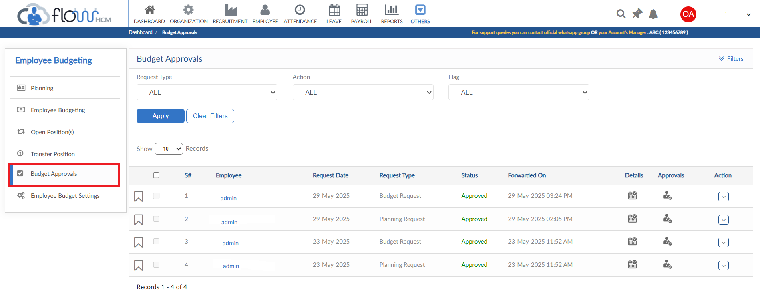

Employee Budget Setting
- In this tab multiple settings are available to set the plan accordingly
- Tab includes to set the duration of plan
- Setting of Position Title
- Employee Position settings
- General settings of Budget planning

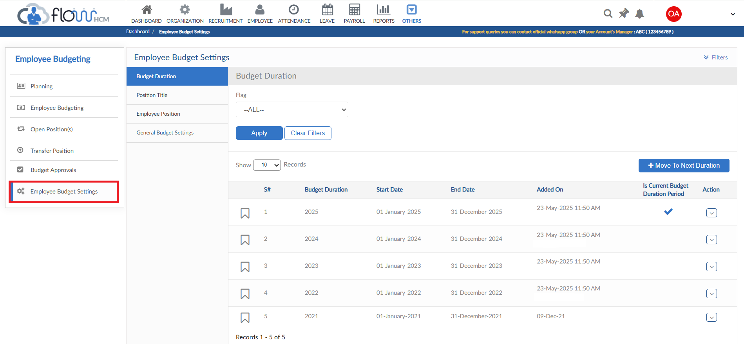

Budget Duration
- The button of Move to Next Duration enables the system to move to next year
- The list shows the durations moved
- Can take required actions in the list for the duration

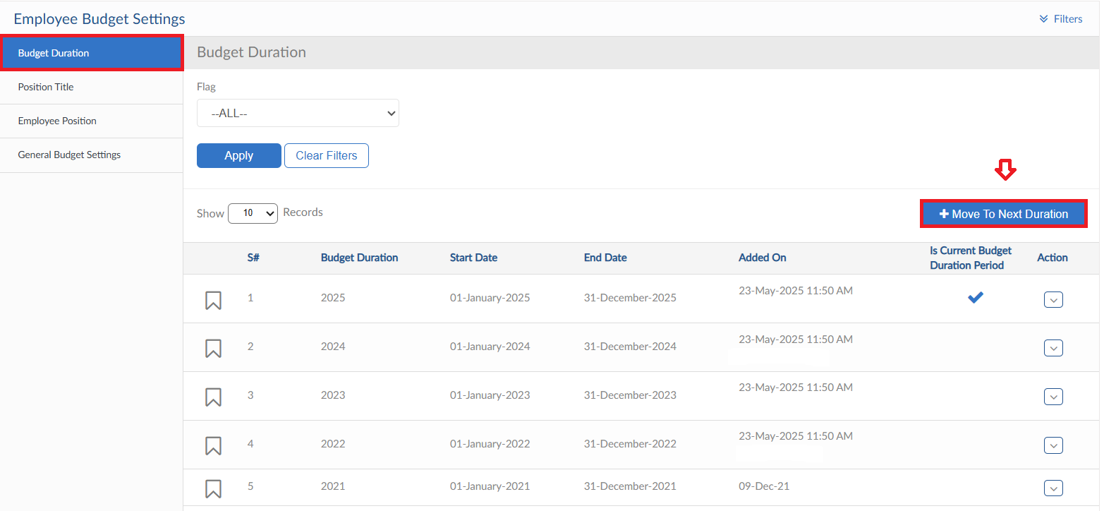

Position Title
- Move to Position title tab, click on Add New Position Title button
- Enter the Position Title
- Additional fields like Key Roles, Job Description and Competencies can be entered as well on check basis. That will impact later on Employee details
- Click on Save button

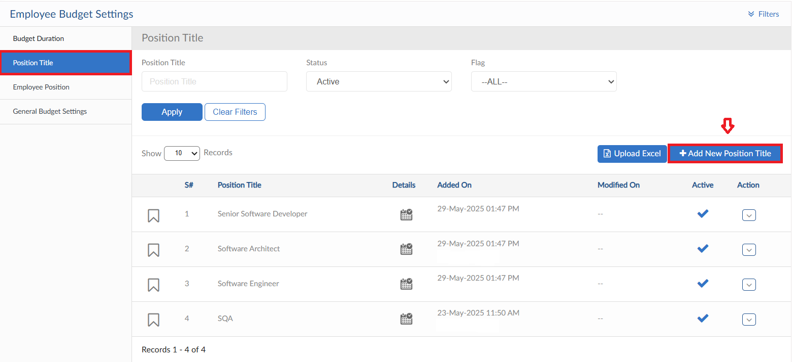
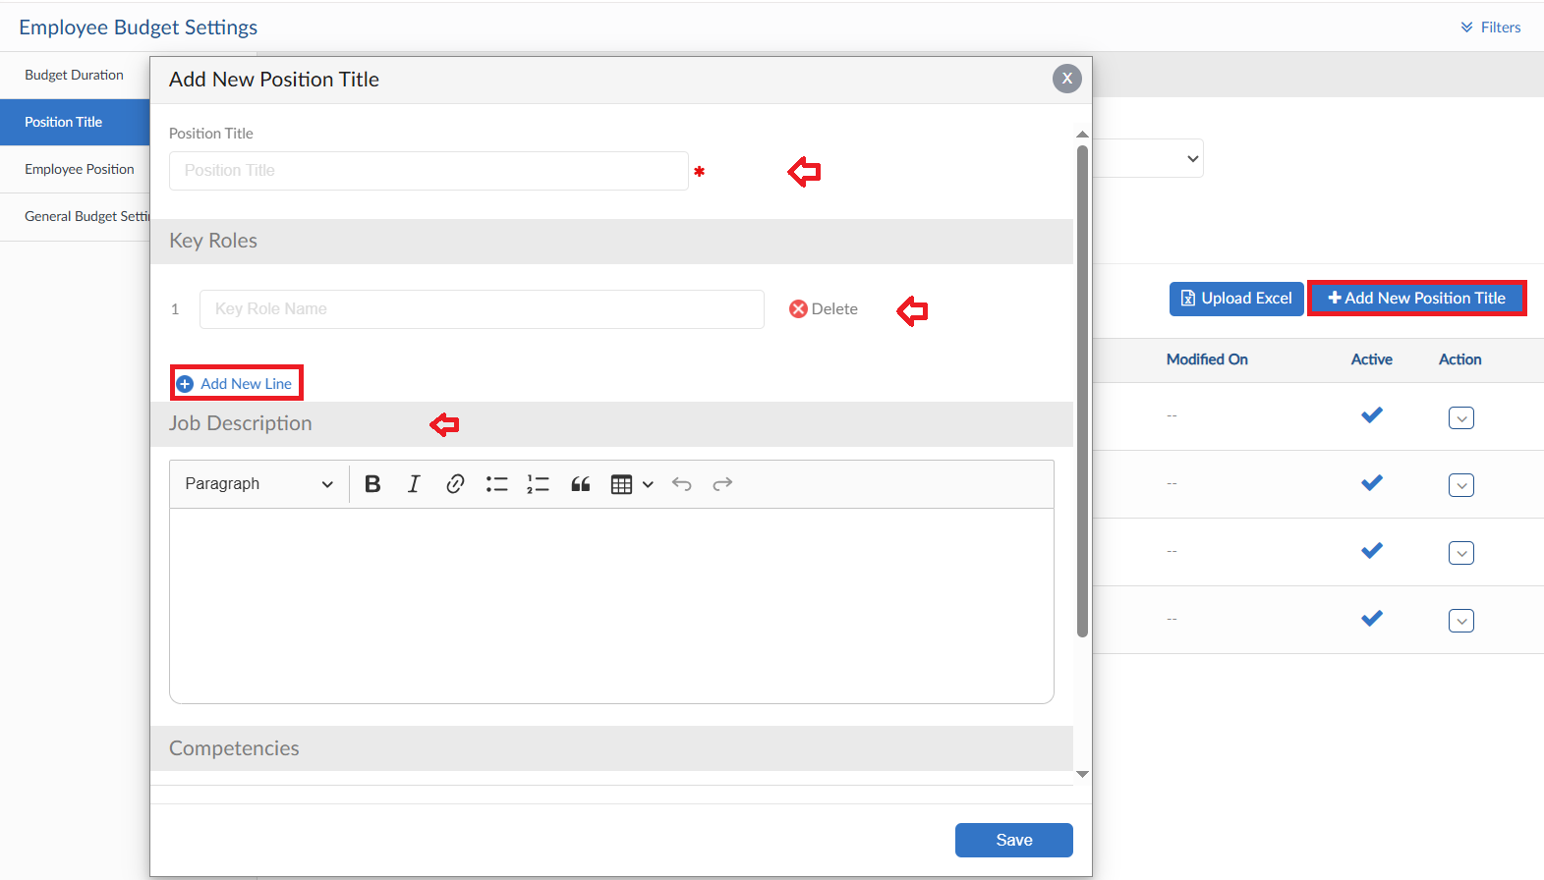
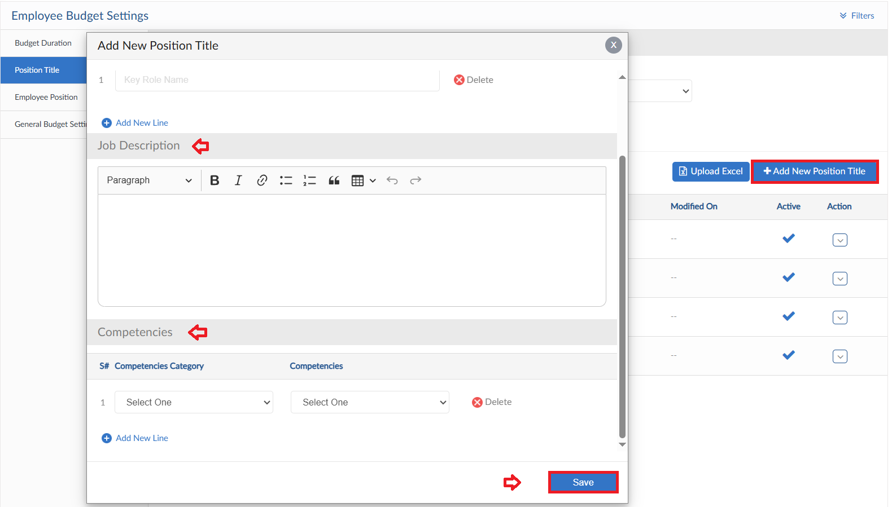

Upload Excel
- If required, upload all Position Titles in one go user can use upload excel
- Click on Upload Excel button, pop up will be visible
- Then click on Download Sample Template and enter required data
- Click on choose file and then click on Save button to upload all Position Titles
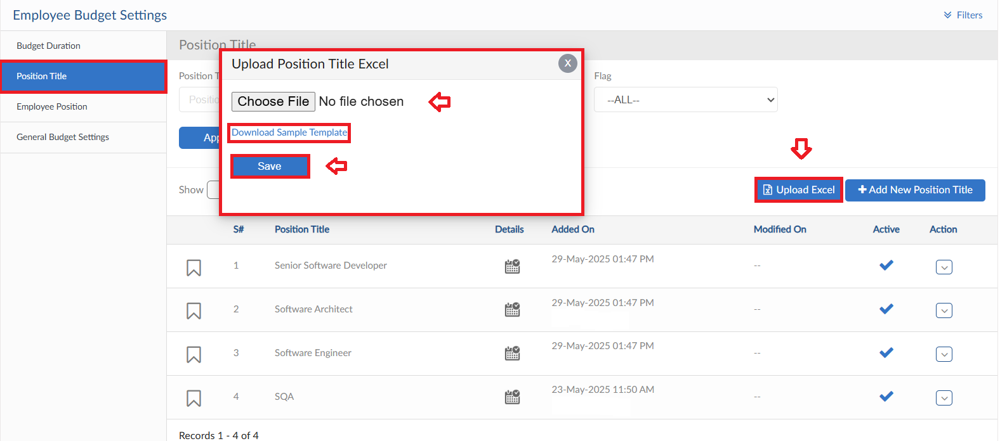

Employee Position
- Move to Employee Position Tab, click on Add new Employee Position
- Enter the required mapping for Position Titles then click on Save button
- Upload excel functionality is also given to upload all Employee Positions at once in bulk
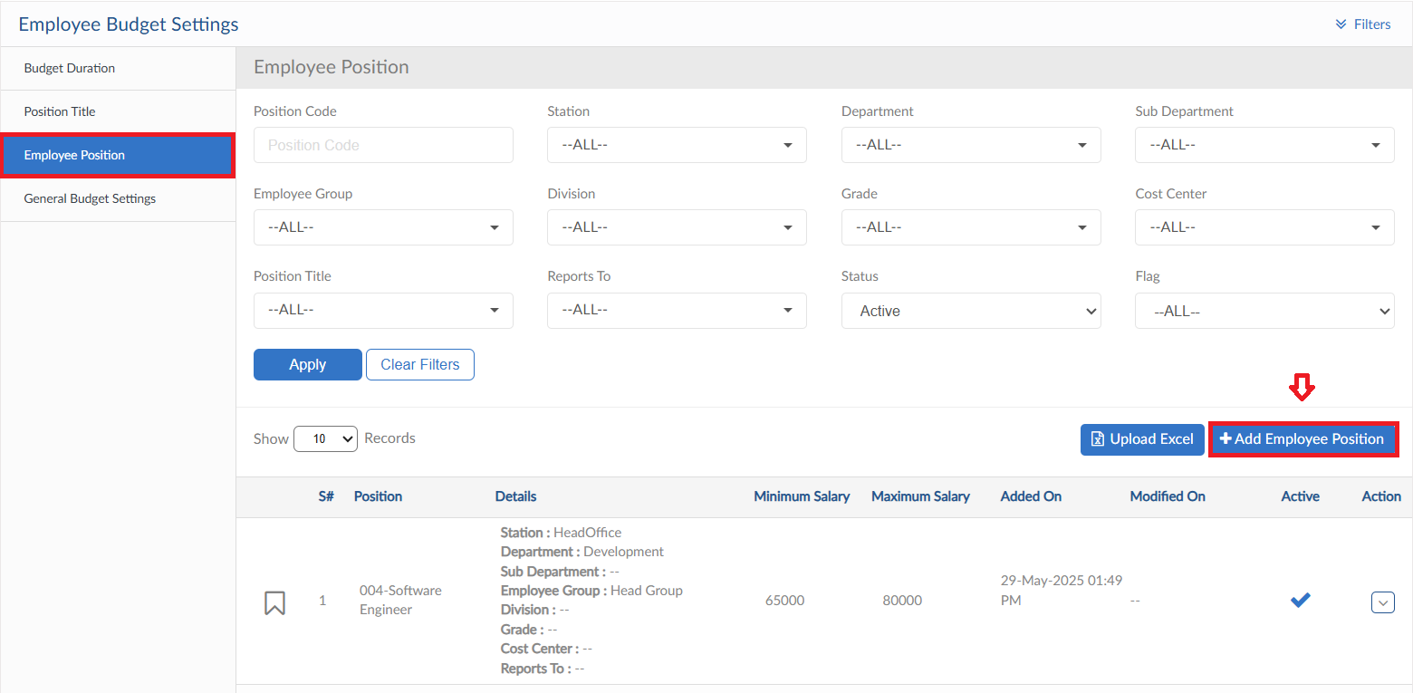
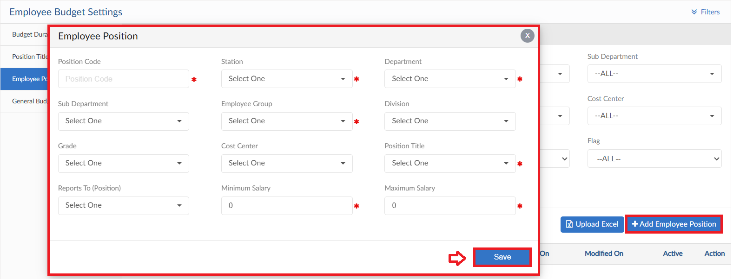

General Setting
- Move to General Setting Tab that includes settings of Budget, Planning and Positions
- Set the budget duration either January or choose a specific date
- Set approval hierarchy either auto or Multi-level approval
- Approvals can be set for Planning, Employee Budget, Open Positions and Transfer Positions
- Two check are given in the last Tab, to auto generate code in Employee Position form and show Change Position form or not
